LeafGuard AI: Predictive Modeling of Plant Stress Using Multisensor

Report submitted to the SASTRA Deemed to be University

as the requirement for the course

ECE300 : MINI PROJECT

Submitted by

kapaka Jahnavi krishna
(Reg No: 227004039, BTech-ECE)
Galam poojitha
(Reg No:227004026, BTech-ECE)



DEPARTMENT OF ELECTRONICS AND COMMUNICATION ENGINEERING

SRINIVASA RAMANUJAN CENTRE

KUMBAKONAM– 612001

MAY 2026



SRINIVASA RAMANUJAN CENTRE

KUMBAKONAM– 612001

Bonafide Certificate

This is to certify that the report titled “LeafGuard AI: Predictive Modeling of Plant Stress Using Multisensor ” submitted in partial fulfilment of the requirements for the award of the degree B.Tech, Electronics and Communication Engineering to the SASTRA Deemed to be University, is a bonafide record of the work done by K.Jahnavi Krishna, Reg no: 227004039 and G.Poojitha,Reg no:227004026 during the sixth semester of the academic year 2025-2026 in the Srinivasa Ramanujan Centre under my supervision. This report has not formed the basis for award of any degree, diploma, associateship, fellowship or other similar title to any candidate of any University.

Signature of Project Guide :

Name of the Guide : Dr.A. SUBRAMANIAN
Date :30-4-2026

Project Viva-Voce held on 01-05-26

Examiner 1 Examiner 2

ii


SRINIVASA RAMANUJAN CENTRE

KUMBAKONAM– 612 001

Declaration

We declare that the report titled “LeafGuard AI: Predictive Modeling of Plant Stress Using Multisensor” submitted by us, is an original work done under the guidance of Dr.A.SUBRAMANIAN Professor Dept of Electrical and Electronics, SRC, SASTRA during the sixth semester of the academic year 2025-2026 in the Department of Electronics and Communication Engineering.

Signature of the candidate(s) :

Name of the candidate(s) :K.Jahnavi Krishna
G.Poojitha
Date :30-04-2026

i

ACKNOWLEDGEMENT

First of all, we would like to thank God Almighty for his endless blessings.

We would like to express our earnest gratitude to Dr. Vaidhyasubramaniam S, Vice-Chancellor for his support during the span of our academic life at SASTRA Deemed University.

We would always stay heartful and we might want to express gratitude towards Dr. Chandramouli R, Registrar for giving an opportunity to do this project.

We would eternally remain thankful and we would like to thank Dr. Santhi. B, Dean of SRC for her irresistible support provided during our course span in SASTRA Deemed University.

We are extremely grateful to Dr. Alli Rani A, Associate Dean (Academics & Research) and Dr. Narasimhan D, Associate Dean (Infrastructure & Student Welfare), for their constant support, incentive and academic help extended for the past six semesters of our life in SASTRA Deemed University.

We would specially thank and express our gratitude to Dr. Saravanan. S, Mini Project Coordinator for providing us an opportunity to do this project and for his leadership and support to successfully complete this project.

We place on record our gratitude to Dr.A.SUBRAMAINAM, Asst. Professor – III, SRC, SASTRA, for his valuable guidance throughout the duration of this project.

We also thank all the Teaching faculty and Non-Teaching staff and all other people who have directly or indirectly helped us through their support, back-up and all otheassistance extended for completion of our project and for successful completion of all courses during our academic life at SASTRA Deemed University.

iv
ABSTRACT
Plants are highly vulnerable to environmental stresses caused by heat, drought, and humidity fluctuations, which significantly reduce growth and yield. This project introduces LeafGuard AI, a predictive framework for plant stress that employs multisensory data and machine learning methodologies. The system uses environmental and physiological factors like temperature, relative humidity (RH), vapor pressure deficit (VPD), volumetric water content (VWC), plant weight, and electrical impedance to check on the health of plants. A representative dataset was utilized, succeeded by preprocessing and feature selection to optimize model efficiency and performance. A combination of Adaboost, decision tree, and random forest, called the Hybrid-AdapTree model, was suggested to make predictions more accurate and easier to understand. The Hybrid-AdapTree model outperformed the others in experimental tests using several regression metrics. It had a R² score of 0.999206 for predicting impedance, a low RMSE of 62.34, and a high Pearson correlation of 0.9996. The model was able to predict temperature with a competitive level of accuracy (R² ≈ 0.88). Also, feature selection makes the training process more efficient while keeping the accuracy high and lowering the amount of computation needed. The obtained results prove the reliability and efficiency of the suggested AI-powered framework in accurate processing of sensor data in order to detect plant stress.

Keywords: Plant stress detection ,Temperature ,Humidity ,vapour pressure deficit(VPD),volumetric water content(VWC),AdapTree algorithm, Machine learning.

v
Table of Contents
TITLE Page No.
Bona fide Certificate ii
Declaration iii
Acknowledgement iv
Abstract v
1. INTRODUCTION 6
1.1 Motivation- Research Purpose and Novelty Justification 8
2. LITERATURE REVIEW 10
3. PROPOSED METHOD 12
3.1 System Overview 12
3.2 Model Training 14
3.3 Data Analysis 11
3.4 Data collection 17
4. RESULTS AND ANALYSIS 18
4.1 Performance Comparison of Regression Models 18
4.2 Feature Importance 20
4.3 Scatter comparison 21
4.4 Model Comparison 22
4.5 Training Time 23
5. CONCLUSION AND FUTURE WORK 24
5.1 Conclusion 24
5.2 Future Work 24

REFERENCES 26

CHAPTER 1
INTRODUCTION
The biological objects themselves are extremely sensitive to external environmental factors such as temperature, relative humidity (RH), and soil or plant impedance. These parameters directly influence physiological processes such as transpiration, nutrient assimilation, and metabolism. Deviations from optimal values may lead to environmental stress, adversely affecting crop productivity and quality. Therefore, the prediction and analysis of these indicators are critical for improving the effectiveness of agricultural production and creating a decision-making support system based on predictive models.
Electrical impedance is an objective parameter characterizing the state of plants, their stress, among other measurable indicators. It reflects changes in internal physiological processes of the plant and is influenced by the moisture content of the plant tissues, cell structure, and environmental factors. Similarly, temperature and RH are atmospheric parameters that characterize the consumption and loss of water in plants due to evaporation. However, the parameters in question are usually interconnected in nonlinear relationships, thus preventing the application of traditional methods of modeling and prediction.
The increasing popularity of ML algorithms is associated with the ability of those techniques to model intricate nonlinear correlations present within the data sets. This approach is aimed at overcoming the identified limitations. MLR and other classic regressions are simple to apply and require minimal computing resources, yet their main limitation is the inability to adequately capture complex relations between the examined variables. In contrast, advanced machine learning techniques, including Decision Trees (DT), K-Nearest Neighbors (KNN), AdaBoost, and Multi-Layer Perceptrons (MLP), provide better prediction outcomes yet are characterized by higher costs, higher risks of overfitting, and high sensitivity to variations in the input data. Ensemble learning approaches enable creating hybrid models by combining several different ML techniques in order to achieve better predictive performance. An example of such a model is AdapTree that uses DT learning combined with the boosting technique (AdaBoost).
AdapTree outperforms single ML models, yet there is room for improvement since additional ensemble strategies could be incorporated into this model together with the enhanced feature selection process. The current research extends the methodology proposed by Garg et al. in Sensors (2025), presenting an improved hybrid model called Hybrid-AdapTree.This recommended model makes use of an ensemble approach involving stacking where the good aspects of decision tree, AdaBoost, and Random Forest models have been combined. The hybrid model manages to take advantage of linear and non-linear relations within the data by employing various learning approaches, thus ensuring greater accuracy and reliability.Pickup of features is quite significant because it reduces model complexity and improves generalization performance.
MI is utilized for evaluating the link between input features and target variables in this research paper. According to the results obtained with MI, useless features such as frequency are omitted from the set of features leaving only a few features consisting of phase, VPD, VWC, and weight. As a result, a reduced number of useful features contributes not only to increased prediction accuracy but also allows achieving a significant reduction in computational costs. The input features include Frequency, Phase, Vapor Pressure Deficit (VPD), Volumetric Water Content (VWC), and Weight. The target variables include Impedance, Relative Humidity (RH), and Temperature. At first, the dataset undergoes several stages of pre-processing which includes data normalizing, splitting into the train/test subsets, and calculating correlations. The correlation matrix is plotted on the heatmap and provides a basis for obtaining information about the importance and dependency of features.
The proposed solution demonstrates a very high level of effectiveness during various experiments which was especially noticeable in case of predicting impedance where the highest R² achieved a level above 0.999. In addition, the efficiency can be further enhanced through introducing the Hybrid-AdapTree with feature selection that allows reducing training time by an average of 53.8%.
Additionally, the paper suggests the Environmental Stress Index (ESI), which categorizes the level of stress in terms of low and moderate by means of using predicted parameters. This approach provides meaningful interpretation of model results and therefore can be beneficial for implementation of the proposed model in practical purposes in smart agriculture. Moreover, the study shows that while the most complex model such as Hybrid-AdapTree demonstrates a high level of prediction accuracy when dealing with impedance, KNN works much better for temperature and RH prediction. This observation shows that appropriate models may have to be used for particular environmental parameters.
Overall, the presented study demonstrates that it is possible to obtain more precise and fast results by means of utilizing hybrid ensemble machine learning algorithms and feature selection procedures. The developed framework can be efficiently applied to various practical uses because of its increased speed of operation and accuracy and therefore it would work well for use in IoT-based monitoring systems and embedded agriculture. Thus, the presented work contributes to the development of smart agricultural systems by creating efficient and scalable models for predicting multiple environmental factors.

1.1 Motivation:Research Purpose and Novelty Justification:
The primary purpose of this study is to enhance plant stress prediction frameworks by developing an optimized framework based on the suggested AdapTree approach. As highlighted in the initial study, the combination of Electrical Impedance Spectroscopy (EIS) and machine learning techniques can efficiently predict essential environmental factors such as impedance, relative humidity (RH), and temperature. While the proposed model has proven highly accurate, it suffers from certain limitations regarding feature selection, computational complexity, and model generalization. The primary purpose of this study is to enhance plant stress prediction frameworks by developing an optimized framework based on the suggested AdapTree approach. As highlighted in the initial study, the combination of Electrical Impedance Spectroscopy (EIS) and machine learning techniques can efficiently predict essential environmental factors such as impedance, relative humidity (RH), and temperature. While the proposed model has proven highly accurate, it suffers from certain limitations regarding feature selection, computational complexity, and model generalization.
However, in the base AdapTree model, there are no dimensionality reduction techniques utilized since all features are included in the analysis. It is primarily a boosted combination of Decision Tree and AdaBoost algorithms.
Such complexity may lead to higher computing costs. Moreover, this learning algorithm cannot benefit from advanced ensembling, including stacking, which would help to achieve better performance when analyzing non-linear data sets.
1. Hybridization of AdapTree Algorithm:
This research proposes a new hybrid model called Hybrid-AdapTree, which extends the initial algorithm by adding stacking-based ensemble approach. As a part of stacking, several algorithms, including decision tree, AdaBoost, and random forest are used in order to obtain different models with various patterns in the dataset. Thus, hybridization increases the ability of the algorithm to analyze complex non-linear relationships and predict results more precisely than in case with basic boosting.
2. Mutual Information based Feature Selection Approach:
One of the innovations made in the paper is application of feature selection based on Mutual Information principle. Instead of using all initial features, the algorithm focuses on important features, such as phase, VPD, VWC, and weight. By doing this, the algorithm reduces the dimensionality and removes unnecessary data, improving its accuracy.
3. Computational Performance Increase
Feature selection helps to significantly reduce the training time. Hybrid-AdapTree with feature selection outperforms the full hybrid model by its computational efficiency.
4. Better predictive performance in several aspects:
The new model is significantly more effective at producing predictions (R² ≈ 0.999) compared to the original AdapTree, as well as any regression models. The proposed model is superior in comparison with the base paper performance (R² ≈ 0.993 for impedance) due to its smaller error rate and hence greater generality and robustness in relation to impedance, RH, and temperature predictions.
5. Development of the architecture which will be more applicable and scalable for the business:
Hybrid ensemble learning, feature selection, and performance tuning improve the applicability of the model and its scalability. The inclusion of Environmental Stress Index (ESI) makes the model more interpretable through translating predictions to practical stress measurements.

CHAPTER 2
LITERATURE REVIEW
Much consideration has been devoted to the application of sensors to monitor plant stress in precision farming. Plant growth and yield depend on various parameters such as adequate temperatures, humidity, light levels, and irrigation. The traditional approach to plant stress detection involves manual visual examination and measurements of physiological indicators. Nevertheless, these approaches are quite time-consuming, subjective, and unsuitable for large fields' monitoring needs. Recent advancements in sensors and artificial intelligence made it possible to develop automated monitoring systems to detect plants' stressed conditions effectively.Many studies focused on image-based methods to detect plant stress. For example,
Liew et al. [1] analyzed the utilization of thermal imaging and fluorescence sensing methods to identify early stages of stress in plants caused by pathogenic infections and unfavorable environmental factors. According to their findings, imaging techniques were effective in detecting plant stress at the stage before any visible changes.
Zhang et al. [2] used UAV-based multispectral imaging to monitor maize cultivation and determine Crop Water Stress Index (CWSI). It was found that combining remote sensing and machine learning techniques was very effective in detecting crop water stress.
Similarly, environmental sensors are crucial in agricultural stress monitoring applications. As part of efforts to gain a deeper understanding of microclimates associated with plants, various sensors have been employed to monitor parameters such as humidity, temperature, and vapor pressure deficit.
Wang et al. [3] evaluated the effect of temperature and humidity variations on physiological responses, reporting that environmental stress significantly impacts metabolism and plant growth patterns. Environmental monitoring combined with physiological sensors can provide additional insights into plant stress levels.Machine learning techniques have become increasingly prevalent in agricultural monitoring systems due to their utility in analyzing complex data from sensors.
Patel et al. [4] demonstrated that sensor data can be incorporated into machine learning models to detect plant diseases and monitor crop health.
Pradhan et al. [5] introduced a machine learning model to predict abiotic stress-responsive microRNAs in plants using Support Vector Machines (SVM). The model had a predictive performance above 80%, indicating the usefulness of machine learning in such tasks.
Several studies have examined advanced machine learning techniques for plant stress prediction problems.
Akbari et al. [6] designed an approach using a machine learning technique with the aid of molecular and phenotypic characteristics to cluster barley genotypes based on their drought and salinity stress resistance. This study was conducted with a neural network model with a coefficient of determination (R²) greater than 0.99, indicating that AI-based models are effective for agricultural applications. Also, studies have focused on developing ensemble learning approaches with the combination of multiple models to make better predictions. The previous literature in the field of plant stress detection mostly considered either one single stress factor or used one single type of sensor, such as imaging sensors or environmental sensors.
The conventional machine learning systems usually fail in identifying the relationship between the environment and plant physiology as plant stress is attributed to numerous variables that influence one another. Recent advancements in the field have centered around developing an integrated approach involving the use of multiple sensors and machine learning algorithms. The new approaches demonstrate the importance of using machine learning in conjunction with the available sensors to identify plant stress in real time.

CHAPTER 3
PROPOSED METHOD
3.1 System Block Diagram:
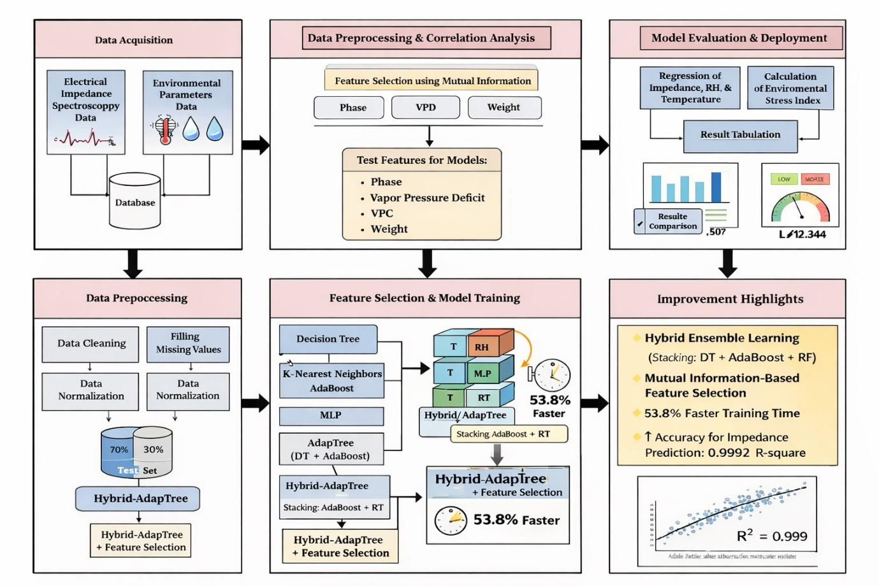

1.Data Acquisition:
Data collection involves gathering information from two main sources, which are:
- Electrical Impedance Spectroscopy (EIS) signals.
- Environmental factors such as temperature, humidity, and moisture related features.
The acquired data will be merged together into one single database.
2. Data Preprocessing & Correlation Analysis:
Preprocessing of the gathered data is required to ensure good quality of data and its consistency. It involves cleaning, managing missing data, and normalizing data to bring all features on a same scale. Correlation analysis is conducted by using heatmap. The most relevant features that would be used later on in machine learning modeling were chosen using Mutual Information. These features include Phase, VPD, VWC, and Weight.
3. Feature Selection and Model Training:
The selected features are employed to train several machine learning models like Decision Tree, K-Nearest Neighbors (KNN), AdaBoost, and Multi-Layer Perceptron (MLP). An ensemble model named AdapTree is built based on the combination of Decision Tree and AdaBoost algorithms. Moreover, a Hybrid-AdapTree model is created utilizing the stacking method, which incorporates AdaBoost and Random Forest algorithm. Feature selection is performed in the Hybrid-AdapTree model as well.
4. Model Evaluation and Stress Index Computation:
The trained models are assessed using regression algorithms to estimate the values of impedance, RH, and temperature. The results are recorded and analyzed using the metrics such as R², RMSE, and MAE. Based on these estimates, Environmental Stress Index (ESI) is computed to identify the plant stress levels.
5. Enhancements of the Proposed Algorithm:
The Hybrid-AdapTree algorithm with feature selection shows major enhancements compared to traditional algorithms. The algorithm provides high prediction accuracy, particularly in terms of impedance with R² ≈ 0.999. In addition, it takes less time for training by about 53.8% compared to existing algorithms.

3.2 Model Training:
The model training step is the development of machine learning models capable of predicting environmental stress indicators, such as impedance, relative humidity (RH), and temperature, by learning from the input data set. In this research, various multiple regression models are utilized to analyze and compare their effectiveness in prediction.
Initially, conventional models including Decision Tree (DT), K-Nearest Neighbor (KNN), Multivariate Linear Regression (MLR), AdaBoost, and Multi-Layer Perceptron (MLP) are created. The Decision Tree model partitions the data set repeatedly to reduce prediction error. This allows the model to identify nonlinear relations between stress parameters in plants. In KNN, the prediction value is calculated using the mean of the closest points in the feature space. Therefore, KNN is effective at identifying patterns within smaller regions of space. The Multivariate Linear Regression (MLR) model serves as the baseline model, which is formulated using the following equation:
yi = bi0 + bi1x1 + bi2x2 + bi3x3 + bi4x4 + bi5x5 + ei
where yi represents the output variables (impedance, RH, temperature), xj are input features, bij are regression coefficients, and ei is the error term.
The application of AdaBoost takes place by building an ensemble approach that utilizes several weak learners to boost model efficiency. In each iteration, the algorithm increases the weight of samples misclassified by the model. The result is calculated as:
ŷ(x) = Σ (alpha_t * ht(x)) for t = 1 to T
Here, ht(x) and alpha_t denote prediction and the weight of the t-th weak learner respectively.
The MLP model is capable of discovering complex and nonlinear dependencies due to its ability to use several hidden layers and activation functions. The model is applicable in processing high-dimensional data.
In order to obtain more precise prediction results, an ensemble learning algorithm named AdapTree is applied. The model combines Decision Tree and AdaBoost algorithms and improves generalization capability of the predictor by reducing both bias and variance. The result can be expressed as follows:
ŷ(x) = alpha1 * hDT(x) + alpha2 * hAdaBoost(x)
where hDT(x) and hAdaBoost(x) are predictions from Decision Tree and AdaBoost models.
Another ensemble learning technique based on stacking is utilized to propose the Hybrid-AdapTree model, which combines Decision Tree, AdaBoost, and Random Forest algorithms in order to successfully model both linear and nonlinear correlations. Further, feature selection techniques are used in order to eliminate the less relevant attributes and reduce the number of dimensions, thus speeding up the computation and decreasing the required training time without affecting the accuracy of the algorithm.
All the models will be trained using the preprocessed data set and their performances will be compared through performance measures such as coefficient of determination (R²), Mean Squared Error (MSE), Root Mean Squared Error (RMSE), Mean Absolute Error (MAE), and Pearson Correlation Coefficient (PCC). All these performance measures guarantee a comprehensive assessment of the proposed model.
The proposed Hybrid-AdapTree with Feature Selection will prove to be a more efficient and effective algorithm.

3.3 Data Analysis:
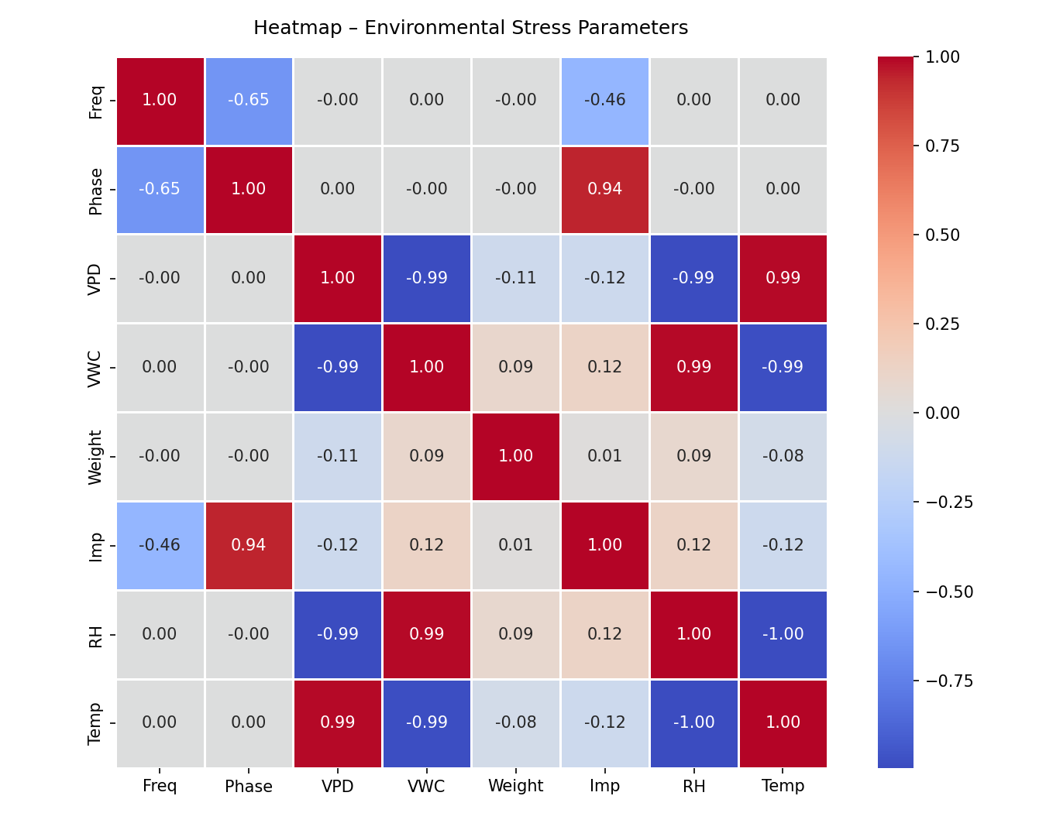
Figure2.Heatmap for environmental stress parameters
Heatmaps present one way of visually representing various interactions between different environmental and electrical factors. A heatmap is a useful representation technique since it clearly depicts relationships between variables of interest. Color intensity in the generated heatmap can be used to infer the strength and nature of correlation between two variables. High positive values signify strong direct relationships while negative values indicate inverse relationship.
A strong positive correlation between Phase and Impedance (≈ 0.94) is evident from the heat map analysis, hence signifying a notable relationship between phase and impedance behaviors. Also, there is a strong positive relationship between VPD and Temperature (≈ 0.99) implying that variations in temperatures greatly influence vapor pressure deficit.
In addition, VPD exhibits strong inverse relationships with VWC (≈ -0.99) and Temperature with RH (≈ -1.00)** due to natural dependency in the environment such that high temperature reduces humidity.Vapor pressure deficit has strong positive correlation with RH (≈ 0.99) hence signifying that the moisture content in the air directly determines humidity levels. Frequency shows weak correlation with most variables, except that it has moderately inverse correlations with Phase (≈ -0.65) and Impedance (≈ -0.46).
In addition, the heatmap may be used as a diagnostic instrument for identifying irrelevant features or features of low significance. The current analysis indicates that certain factors such as frequency are less correlated with the target parameters than in the base paper in which all of the features were included. This data confirms the relevance of the use of feature selection for improving the effectiveness of the algorithm developed within the framework of the proposed research.
The analysis provided by the heatmap proves that selected features have correlations with the target parameters, while environmental parameters demonstrate high intercorrelation. Such an analysis may help you identify data structure and create accurate predictive models.

3.4 Data Collection:

The gathered dataset undergoes systematic preprocessing to ensure that the machine learning models receive high-quality input data. Initially, sensor data obtained through electrical impedance and environmental monitoring are integrated into one dataset. The subsequent process involves removal of noise and other inconsistencies that might negatively affect the performance of the machine learning model.

To maintain the integrity of the dataset and prevent data loss during preprocessing, appropriate imputation techniques should be employed for handling missing values. Normalization is done to align all the feature values within a single range in order to make the machine learning models converge and become stable. Such a crucial preprocessing stage is necessary considering that the data consists of different parameters such as frequency, impedance, and temperature measured in various units.Once the preprocessing stage is over, the obtained dataset should be randomly split into training and testing datasets. Specifically, the ratio between the training dataset and the testing one should be set at 70% and 30% respectively. While the former is used to train machine learning models, the latter serves to validate those models by evaluating their performance on unseen test data.

Moreover, Mutual Information is employed in the process of feature selection, which evaluates the relationship between the input features and the target variable. By reducing the redundant input features, the process eliminates unnecessary computational load and focuses more attention on the most critical parameters, making the model more effective.
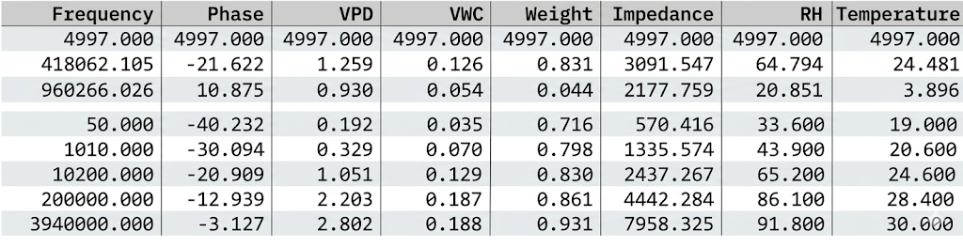
Table 1: Sample dataset

CHAPTER 4
RESULTS AND DISCUSSION
4.1Performance Comparison of Regression Models
Performance comparisons of several machine learning algorithms to predict environmental stress factors like impedance, relative humidity (RH), and temperature are listed in tables 1 to 3. These models consist of traditional algorithms such as Decision Tree (DT), K-Nearest Neighbor (KNN), Multiple Linear Regression (MLR), Adaboost, Multi-Layer Perceptron (MLP), and the newly developed Hybrid-AdapTree models. The performance of these algorithms is assessed based on metrics such as R², MSE, RMSE, MAE, and Pearson Correlation Coefficient (PCC).
Table 1: Comparison of regression models for impedance parameter of environmental stress
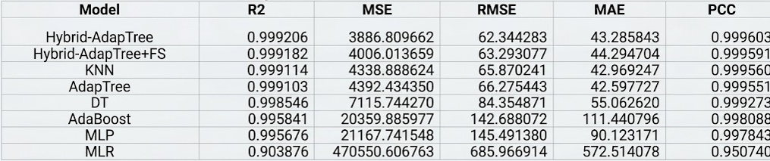
Among all the proposed models, the Hybrid-AdapTree algorithm achieved the highest prediction accuracy regarding the impedance parameter, with an R² score of 0.999206 and a PCC of 0.999603. The hybrid approach has significantly lower error values (RMSE: 62.34; MAE: 43.28) compared to the conventional techniques. The hybrid method with feature selection performed similarly but was slightly less accurate and efficient. The traditional methods, such as MLR, were ineffective due to the insufficient performance, low R² (0.903876), and extremely high error rates. Thus, they were unable to capture any nonlinear dependencies. Meanwhile, the KNN and AdapTree algorithms performed decently, but the proposed approach is slightly superior. The results reveal that the hybrid ensemble technique improves the predictive capabilities by integrating multiple learners. Therefore, the presented findings confirm that the Hybrid-AdapTree approach provides the highest prediction accuracy concerning the impedance parameter, which is the key criterion in identifying plant stress

Table 2: Comparison of regression models for humidity parameter of environmental stress
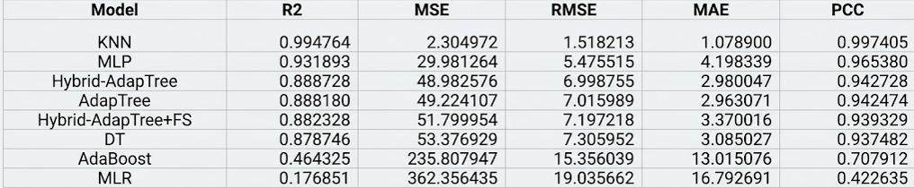
However, when it came to the prediction of the relative humidity (RH), KNN was the best, having the highest R² of 0.994764 compared to other models. It may be assumed that the suggested Hybrid-AdapTree and AdapTree models performed fairly well with R² about 0.88. Hybrid modeling performed poorly when predicting RH, which implies that a single-model solution would be better at forecasting relative humidity due to the smoothness of the corresponding data.
Again, KNN performed best with the highest R² of 0.988274 for temperature prediction. After that, the Hybrid-AdapTree with Feature Selection had the second place by R² of 0.884201. As it has been shown above, AdapTree and Hybrid-AdapTree had almost identical R² about 0.88. From this, one can conclude that the lower error values of KNN show that this model can effectively predict temperature variations. Meanwhile, hybrid models perform fairly well in terms of generalization across all the parameters, while single models work well only under certain conditions.
It should be noted that AdapTree was the best in impedance prediction due to the capacity to detect complex non-linear physiological dependencies. Hybrid Stacking enhances this feature. Another contribution made by the authors is the impact of feature selection on predictive performance.The Hybrid-AdapTree with Feature Selection approach provides a very similar level of classification accuracy to the original hybrid approach but is more efficient in terms of training time since it saves up to 53.8% of computation time. This demonstrates that eliminating some features does not negatively affect the algorithm's performance.
Table 3: Comparison of regression models for temperature parameter of environmental stress
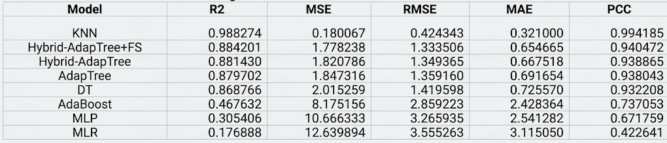
In conclusion, the suggested Hybrid-AdapTree model has been found to be the most suitable overall, particularly for impedance prediction despite the fact that the KNN method performed excellently for the prediction of RH and temperature. This is based on the effectiveness and efficiency associated with the combination of hybrid ensemble learning together with the feature selection process. The suggested model, therefore, becomes an effective technique that can be employed in environmental stress monitoring in real-time. From these findings, it is clear why it is vital to employ several machine learning models along with the optimization of feature sets in order to attain a higher predictive performance level.

4.2 Feature Importance:
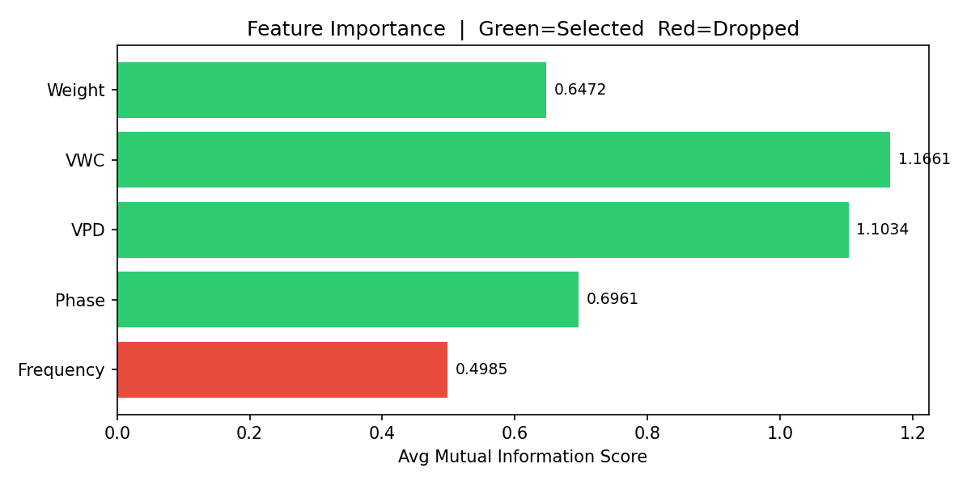
Mutual Information (MI) method was applied for feature importance analysis, which allows understanding the degree to which particular input variables influence prediction of environmental stress parameters. Feature importance plot presented shows that the most relevant variables with MI scores 1.1661 and 1.1034 belong to Volumetric Water Content (VWC) and Vapor Pressure Deficit (VPD), respectively. It can be concluded that the above features play an important role in the process of prediction of impedance, relative humidity, and temperature. Such features are highly important in case of stress analysis as they represent plant-water-environmental relations.
Also, the phase parameter (0.6961) and Weight (0.6472) showed relatively high mutual information values. In fact, they can help detect changes in plants' physiological states. Therefore, the above two features are to be considered in order to ensure appropriate representation of plant responses.
At the same time, frequency was shown to be a rather weakly relevant feature having the minimum MI value equal to 0.4985. Frequency was not considered further due to low mutual information values. Elimination of frequency helps reduce redundancy and make calculations easier without compromising results significantly.Overall, the feature selection technique performed well in reducing the size of the initial input set to just four significant features, which are Phase, VPD, VWC, and Weight. The resulting optimized feature set not only enhances the model’s performance but also enables it to generate accurate predictions. In addition, by eliminating unnecessary features, the learning process becomes faster, enhancing the model’s generalization capabilities.

4.3 Scatter Comparision

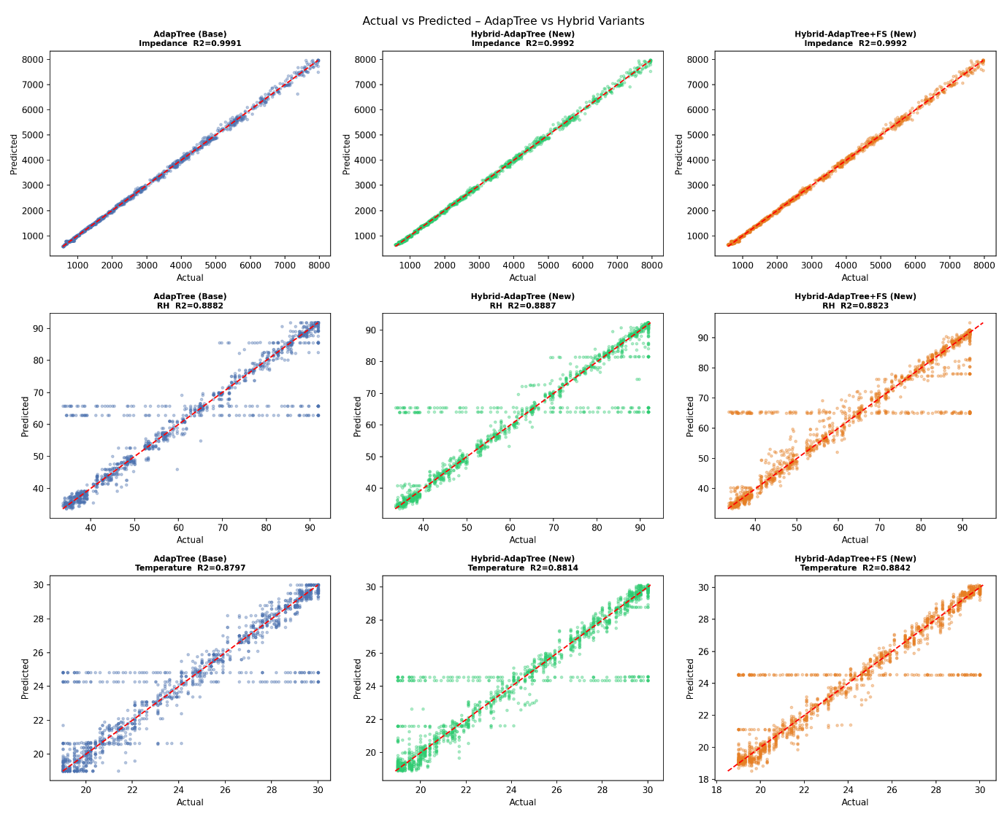
Scatter plots demonstrate the relationship between the actual and predicted values of impedance, relative humidity (RH) and temperature in the AdapTree model and the hybrid proposed models. Points near to the diagonal line demonstrate better accuracy of the models.
Impedance predictions of all models exhibit points close to the diagonal line. Moreover, R² values for all models are rather high (approximately 0.999). Hybrid-AdapTree and Hybrid-AdapTree with Feature Selection models demonstrate higher consistency between each other that shows the superiority of these two models compared to the AdapTree model. For the RH predictions, points of the two hybrid models do not deviate significantly from the diagonal line, although their values are a little bit higher than those for the AdapTree (approximately 0.88). Again, Hybrid-AdapTree model predicts a little bit better than AdapTree one; however, feature selection makes almost no difference here.
Temperature predictions are again following the trend of the diagonal line with R² values being equal to approximately 0.88. Once again, feature selection slightly improves the alignment.
Plots demonstrate superiority of the proposed Hybrid-AdapTree models in terms of predicting values accurately and consistently.

4.4 Model Comparison:
Based on the above table depicting the values of R² and RMSE for all the models, it can be concluded that the Hybrid-AdapTree proposed model is most suited to predict impedance since it has the highest R² value of 0.9992 and lowest RMSE value of 62; hence, this model has been shown to have higher accuracy compared to other models. On the other hand, the Hybrid-AdapTree with feature selection model performs similarly except with minimal errors, performing even better in some cases.
The best algorithm for predicting relative humidity and temperature parameters is the KNN algorithm because it has the highest R² values and lowest RMSE value for these two parameters. In this way, it is demonstrated to handle them effectively. The Hybrid-AdapTree algorithms have been shown to work quite well across all parameters although not as effectively as single models which work well under specific conditions.
MLR traditional model, on the other hand, gives worst results with high errors while AdaBoost, Decision Trees (DT) and MLP work reasonably well
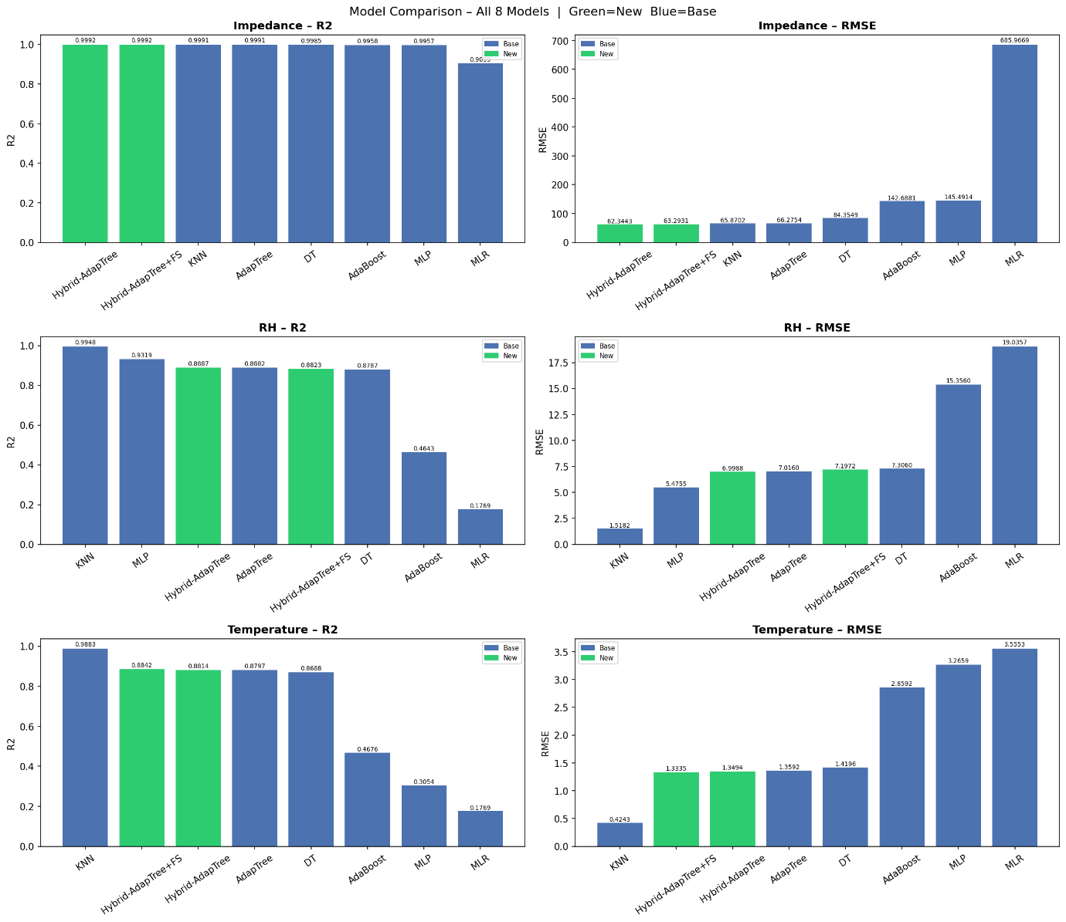

4.5 Training Time:

It becomes evident from the comparative analysis of the training time that an increase in complexity of a predictive model implies a longer computation period. Thus, Hybrid-AdapTree, a stacker consisting of several learners, requires significantly longer training times compared to other methods and equals 15.7 seconds.

At the same time, the Hybrid-AdapTree with Feature Selection manages to train models in just 6.6 seconds and at the same time increase performance by 53% while maintaining the same level of accuracy as the model without feature selection. The above results prove the efficiency of the application of feature selection techniques to models.

Furthermore, MLP also requires a significant amount of computation time equaling 6.09 seconds. On the contrary, KNN, DT, and MLR require minimum training time but fail to provide high-quality predictions. It can be concluded that hybrid algorithms are difficult to compute; however, they become applicable when feature selection is employed.

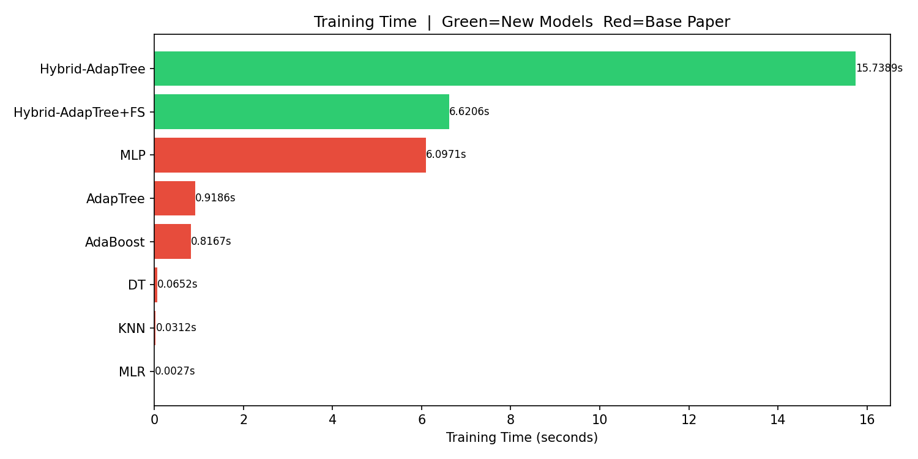

CHAPTER 5
CONCLUSION AND FUTURE WORK
5.1 Conclusion
This work developed an improved machine learning framework for predicting environmental stress parameters like impedance, relative humidity (RH), and temperature using data from sensors. We used and tested several multiple regression models, and we suggested a Hybrid-AdapTree model to make predictions more accurate by combining the best parts of different learning algorithms.The results show that the suggested Hybrid-AdapTree model works better than other models, especially for predicting impedance, with very high accuracy (R² ≈ 0.999) and low error rates. KNN and other models do better for RH and temperature on their own, but the hybrid model works well for all parameters.
This shows how ensemble learning can find complicated nonlinear relationships in environmental and physiological data.The model is even better with feature selection using Mutual Information because it gets rid of less important features, lowers the number of dimensions, and makes the calculations faster. The Hybrid-AdapTree with Feature Selection cuts down on training time a lot while keeping the same level of accuracy, making it better for real-time use.
Moreover, the introduction of an Environmental Stress Index (ESI) helps in the comprehension of the predicted values through categorization according to the level of stress, which could help in making decisions regarding the agricultural systems. The presented technique is superior to existing models in both accuracy and efficiency. An efficient approach for monitoring environmental stress would be through the hybrid of ensemble learning and feature selection. This could be of great significance in areas such as precision agriculture and smart farming.

5.2 Future Work
Several natural extensions of the present work present compelling research directions:
- Integration of Additional Sensors: Future work can include more environmental parameters such as light intensity, soil nutrients, and CO₂ levels to improve prediction accuracy and provide a more comprehensive plant stress analysis.
- Real-Time IoT Implementation: The model can be deployed on embedded systems or IoT platforms for real-time monitoring and automated decision-making in smart agriculture systems.
- Application to Diverse Crops: Testing the model on different plant species and under varying field conditions can improve its generalization and make it applicable to large-scale agricultural environments.
- Advanced Model Enhancement: Incorporating deep learning or hybrid ensemble techniques can further improve prediction performance, especially for complex parameters like humidity and temperature.
- Explainable AI and Optimization: Applying explainable AI (XAI) techniques can improve model interpretability, while optimization methods can reduce computational cost and enhance real-time efficiency.

REFERENCES
[1] H. M. Jawad, R. Nordin, S. K. Gharghan, A. M. Jawad, and M. Ismail, 'Energy-efficient wireless sensor networks for precision agriculture: A review,' Sensors, vol. 17, no. 8, p. 1781, 2017.
[2] K. G. Liakos, P. Busato, D. Moshou, S. Pearson, and D. Bochtis, 'Machine learning in agriculture: A review,' Sensors, vol. 18, no. 8, p. 2674, 2018.
[3] S. Adla, N. V. Rai, K. Karumanchi, S. Tripathi, A. Disse, and S. Pande, 'Laboratory calibration and performance evaluation of low-cost capacitive and very low-cost resistive soil moisture sensors,' Sensors, vol. 20, no. 2, p. 363, 2020.
[4] A. Sharma, E. Jain, P. Gupta, and V. Chowdary, 'Machine learning applications for precision agriculture: A comprehensive review,' IEEE Access, vol. 9, pp. 4843–4873, 2021.
[5] H. R. Bogena, J. A. Huisman, H. Schilling, A. Weuthen, and H. Vereecken, 'Effective calibration of low-cost soil water content sensors,' Sensors, vol. 17, no. 1, p. 208, 2017.
[6] F. Kizito et al., 'Frequency, electrical conductivity and temperature analysis of a low-cost capacitance soil moisture sensor,' Journal of Hydrology, vol. 352, no. 3–4, pp. 367–378, 2008.
[7] U. Rosenbaum, J. A. Huisman, J. Vrba, H. Vereecken, and H. R. Bogena, 'Correction of temperature and electrical conductivity effects on dielectric permittivity measurements with ECH2O sensors,' Vadose Zone Journal, vol. 10, no. 2, pp. 582–593, 2011.
[8] K. Ni, N. Ramanathan, M. N. H. Chehade, L. Balzano, S. Nair, S. Zahedi, E. Kohler, G. Pottie, M. Hansen, and M. Srivastava, 'Sensor network data fault types,' ACM Trans. Sensor Networks, vol. 5, no. 3, pp. 1–29, 2009.
[9] C. Zhang, D. Song, Y. Chen, X. Feng, C. Lumezanu, W. Cheng, J. Chen, G. Ni, B. Zong, and N. V. Chawla, 'A deep neural network for unsupervised anomaly detection and diagnosis in multivariate time series data,' in Proc. AAAI Conf. Artif. Intell., 2019, vol. 33, pp. 1409–1416.
[10] M. S. Hossain, G. Muhammad, and N. Guizani, 'Explainable AI and mass surveillance system-based healthcare framework to combat COVID-19 like pandemics,' IEEE Network, vol. 34, no. 4, pp. 126–132, 2020.
[11] D. J. Cook, N. C. Krishnan, and P. Rashidi, 'Activity discovery and activity recognition: A new partnership,' IEEE Trans. Cybern., vol. 43, no. 3, pp. 820–828, 2013.
[12] A. Chlingaryan, S. Sukkarieh, and B. Whelan, 'Machine learning approaches for crop yield prediction and nitrogen status estimation in precision agriculture: A review,' Comput. Electron. Agric., vol. 151, pp. 61–69, 2018.
[13] V. Sehgal, S. Sehgal, S. Bhatt, and A. Sehgal, 'IoT-based smart agriculture and farming,' in Proc. Int. Conf. Innov. Inf. Commun. Technol., 2019.
[14] S. Banerjee, R. Choudhary, and J. De, 'Precision agriculture: A data mining approach for prediction of soil properties,' in Proc. Int. Conf. Comput. Intell. Data Sci., 2020.
[15] N. Ahmed, D. De, and I. Hussain, 'Internet of Things (IoT) for smart precision agriculture and farming in rural areas,' IEEE Internet Things J., vol. 5, no. 6, pp. 4890–4899, 2018.
[16] P. Cunningham and S. J. Delany, 'k-nearest neighbour classifiers—A tutorial,' ACM Comput. Surv., vol. 54, no. 6, pp. 1–25, 2021.
[17] N. Papernot and P. McDaniel, 'Deep k-nearest neighbors: Towards confident, interpretable and robust deep learning,' arXiv preprint arXiv:1803.04765, 2018.
[18] P. Warden and D. Situnayake, TinyML: Machine Learning with TensorFlow Lite on Arduino and Ultra-Low-Power Microcontrollers. O'Reilly Media, 2019.
[19] J. Lim, J. Bae, and J.-H. Lee, 'Embedded system implementation of k-nearest neighbors with reduced computational complexity,' IEEE Embedded Syst. Lett., vol. 13, no. 2, pp. 62–65, 2021.
[20] J. Lee, F. Wu, W. Zhao, M. Ghaffari, L. Liao, and D. Siegel, 'Prognostics and health management design for rotary machinery systems—Reviews, methodology and applications,' Mech. Syst. Signal Process., vol. 42, no. 1–2, pp. 314–334, 2014.
[21] Q. Qi and F. Tao, 'Digital twin and big data towards smart manufacturing and Industry 4.0: 360 degree comparison,' IEEE Access, vol. 6, pp. 3585–3593, 2018.
[22] G. A. Susto, A. Schirru, S. Pampuri, S. McLoone, and A. Beghi, 'Machine learning for predictive maintenance: A multiple classifier approach,' IEEE Trans. Ind. Inform., vol. 11, no. 3, pp. 812–820, 2015.
[23] R. Lan, Y. Liu, G. Gao, Z. Lu, Y. Sun, and X. Luo, 'Survey of data quality issues in Internet of Things: Taxonomy, open challenges, and future research directions,' IEEE Access, vol. 9, pp. 6561–6576, 2021.
[24] A. Ault, J. Sorber, K. Kotz, and D. Bhatt, 'Remote sensing and IoT-based calibration for precision irrigation,' in Proc. ACM Int. Conf. Embedded Networked Sensor Syst., 2020.
[25] M. Goldstein and S. Uchida, 'A comparative evaluation of unsupervised anomaly detection algorithms for multivariate data,' PLOS ONE, vol. 11, no. 4, 2016.
[26] F. Pedregosa et al., 'Scikit-learn: Machine learning in Python,' J. Mach. Learn. Res., vol. 12, pp. 2825–2830, 2011.
[27] J. S. Camargo, A. F. Lima, M. A. S. Trindade, L. R. Manzione, and J. C. Bereta, 'A low-cost IoT sensor node for monitoring soil parameters and its application in precision agriculture,' Sensors, vol. 21, no. 16, p. 5414, 2021.
[28] S. Wolfert, L. Ge, C. Verdouw, and M. J. Bogaardt, 'Big data in smart farming—A review,' Agric. Syst., vol. 153, pp. 69–80, 2017.
[29] Z. Kaleem, A. Rehan, M. Rehan, M. S. Khan, and C. R. Anderson, 'Low-power wide-area IoT networks for smart agriculture,' in Proc. IEEE Int. Conf. Signal Process. Commun., 2019.
[30] J. Schmidhuber, 'Deep learning in neural networks: An overview,' Neural Networks, vol. 61, pp. 85–117, 2015.



